NanoBio4Can: Secondment Final Report Template

Call: HORIZON-MSCA-2022-COFUND-01
Type of Action: HORIZON TMA MSCA Cofund Postdoctoral Program
Project Title: Nanobiotechnologies for Innovative Therapeutic Approaches for Cancer
Project Acronym: NanoBio4Can
EU Project ID: 101126492
TUBITAK project ID: 123C460
Fellowship Duration: Max 24 months/Fellow
Project Timeline: 01 Nov 2023-31 October 2028
Overall Project Duration: 60 Months

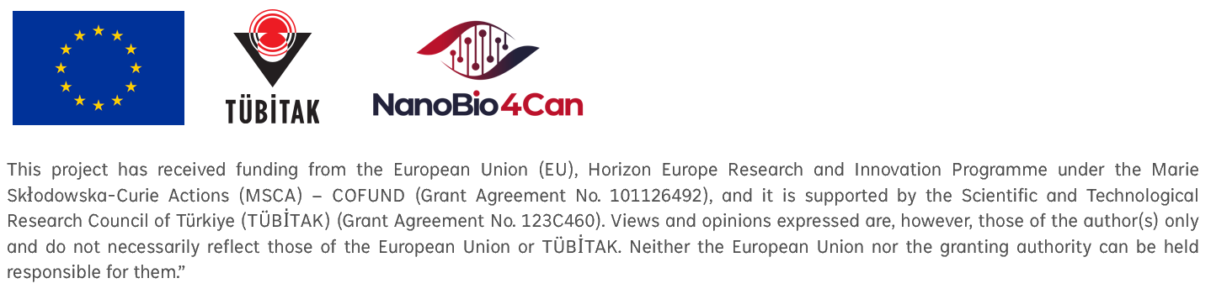

General Information
Seconded Person: [Name, Position]:
Home Institution: [Institution, Country]:
Host Institution: [Institution, Country]:
Duration of Secondment: [Start date – End date, total months/weeks]:
Project Title and Acronym: [if applicable]:

Objectives of the Secondment

Explain why the secondment was planned.

Link to project work packages, deliverables, or personal career development plan.

Activities Undertaken

Research tasks performed

Training/mentoring received

Participation in workshops, meetings, and conferences

Networking and collaboration activities

Outcomes & Achievements

Scientific/technical results obtained

Skills gained (technical, transferable, managerial)

Knowledge transfer (what was shared with the host & what will be brought back)

Any joint publications, proposals, or spin-off collaborations initiated

Impact

Contribution to project objectives / WPs

Contribution to the fellow’s career development/host institution

Added value for consortium, EU, or wider community

Challenges & Lessons Learned

Logistical, administrative, or technical difficulties (if any)

How they were solved, and recommendations for future secondments

Next Steps

Planned follow-up collaboration

Dissemination/exploitation actions (papers, presentations, IP, etc.)

Integration of outcomes into the home institution’s activities

Annexes (optional)

Agenda of meetings

List of publications/presentations resulting from secondment

Photos from events

Version History
Version | Date | Authors | Changes
1.0 | 20.10.2025 | Project Management Team | Initial public release on the website

