NanoBio4Can: Career Development Plan and Key Performance Indicators

Call: HORIZON-MSCA-2022-COFUND-01
Type of Action: HORIZON TMA MSCA Cofund Postdoctoral Program
Project Title: Nanobiotechnologies for Innovative Therapeutic Approaches for Cancer
Project Acronym: NanoBio4Can
EU Project ID: 101126492
TUBITAK project ID: 123C460
Fellowship Duration: Max 24 months/Fellow
Project Timeline: 01 Nov 2023-31 October 2028
Overall Project Duration: 60 Months

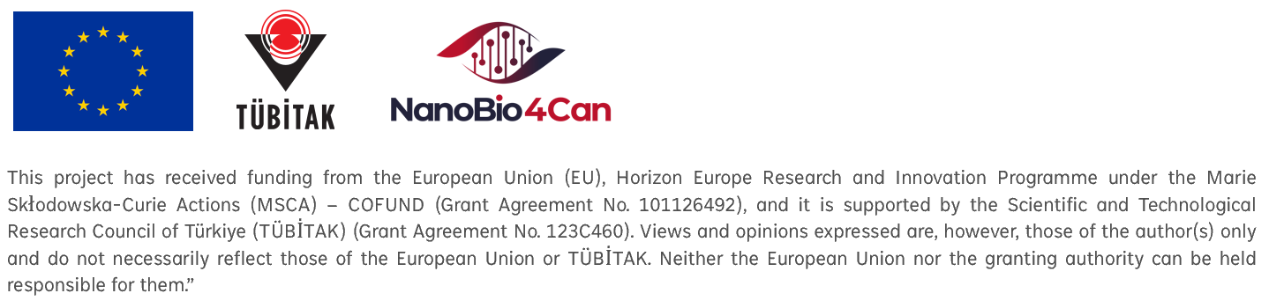

Name of MSCA Fellow:

Institution:

Title of the Project:

Fellow full name: | Date | Signature
Supervisor’s full name: | Date | Signature
Co-supervisor’s full name: | Date | Signature
Project Coordinator full name: | Date | Signature

Abstract
The NanoBio4Can project objectives emphasize high-quality, individualized training for Early Researchers (ERs) in scientific and transferable skills, interdisciplinary competencies, and entrepreneurship, especially in Work Package 4. Key activities include preparing and reviewing training events, receiving guidance from advisors and co-advisors who provide support tailored to each ER's needs, and developing personal career development plans (PCDPs) alongside secondment opportunities.
Advisors and co-advisors are crucial in facilitating skill development, offering insights into career pathways, and helping ERs navigate their research environments. Participants are encouraged to engage in events such as seminars, workshops, and conferences to enhance their skills and maximize career impact. Training also focuses on communication and dissemination skills in collaboration with WP4. ERs are involved in outreach activities to engage the public, including publishing research papers and participating in conferences, Lab Open Days, and webinars.
The program will regularly monitor these activities against Key Performance Indicators (KPIs) to ensure effectiveness and implement corrective measures whenever necessary.

Keywords: NanoBio4Can; Career Development Plan; Key Performance Indicators

Important Notes
- It is mandatory to send a copy of the articles/abstracts accepted for publication and the submitted notifications to the relevant group at TUBITAK 15 days before publication or presentation. The support of TUBITAK and the Horizon Europe Marie Sklodowska-Curie Research Programs and Scholarships must be acknowledged in articles, conference abstracts, and papers published within the project's scope in Turkey or abroad. However, it cannot be stated that these publications or papers were produced by TUBITAK or in cooperation with TUBITAK, and statements that can be interpreted in this manner cannot be used. Please follow the publication guideline document available on the project website.
- In a suitable part of the publications or notifications in question, the following statement will be used only in text form: “This publication/notification was created by benefiting from the 2236-B Marie Sklodowska-Curie Actions (MSCA) Cofund Scholarship Programs Contribution Fund Program (TUBITAK project ID: 123C460) and Horizon MSCA CoFund Postdoctoral Program (EU project ID: 101126492). Please follow the publication guideline document available on the project website.
- However, all responsibility regarding the publication/notification belongs to the owner of the publication/notification. The financial support received from TUBITAK does not mean that TUBITAK has approved the content of the publication/notification in a scientific sense.” In cases where confidentiality is required, such as security and commercial interests, compliance with confidentiality requirements.
- The recruited researchers must work exclusively on the research training activities under the action, unless part-time work for professional reasons is allowed and has been approved by the European Commission. Any supplementary professional activities require either the shift to a part-time implementation of the fellowship (for postdoctoral programmes only) or an interruption of the fellowship (for doctoral and postdoctoral programmes).
- The Commission does not allow overlaps between the COFUND fellowship and other funded projects. To remain fully compliant with the programme requirements, we recommend that fellows submit applications for additional national or international projects during the final 6–8 months of their fellowship, so that the implementation of these projects can commence after the COFUND fellowship has been completed.

Overview of the Research Project (200 words maximum)

Major Accomplishments and Outputs Expected (200 words maximum)

Career Development Objectives within the Project Lifetime (KPIs)

Research Output
Publications

Conferences

Secondment Plan

The institution where the secondment will occur must be selected from the Associated Partners/Secondment Organizations List only. Additionally, before commencing the secondment, an application dossier, including a signed secondment plan and a signed secondment agreement, must be submitted to the coordinating institution. The description, conditions, location, and timetable for implementing the secondment must be detailed in the application document, which is available on the project website.

Skill Development Plan within the Project Lifetime
Seminars/Other Talks

Workshops

Award Application Plans within the Project Lifetime
Achievement Awards (Travel, Publication, Presentation, or Posters)

Teaching Activities Planned within the Project Lifetime
Lectures/Special Topics/Invited Lectures

Mentorship Activities (Undergraduate, Master's, or PhD students) planned within the Project Lifetime
Student Name and Surname | Education Level | Research Field

Research Funding Management or Project Plans
The Commission does not allow overlaps between the COFUND fellowship and other funded projects. To remain fully compliant with the programme requirements, we recommend that fellows submit applications for additional national or international projects during the final 6–8 months of their fellowship, so that the implementation of these projects can commence after the COFUND fellowship has been completed. This approach would both safeguard the fellows’ career development opportunities and ensure that no overlap arises with their full-time COFUND duties.
Academic Projects

Industrial Projects

Fellowships

Other activities with professional relevance (community, citizenship, etc.) planned within Project Lifetime

Long-Term Career Objectives (over 5 years, 200 words maximum)

Other

Version History
Version | Date | Authors | Changes
1.0 | 02.09.2025 | Project Management Team | Initial public release on the website

